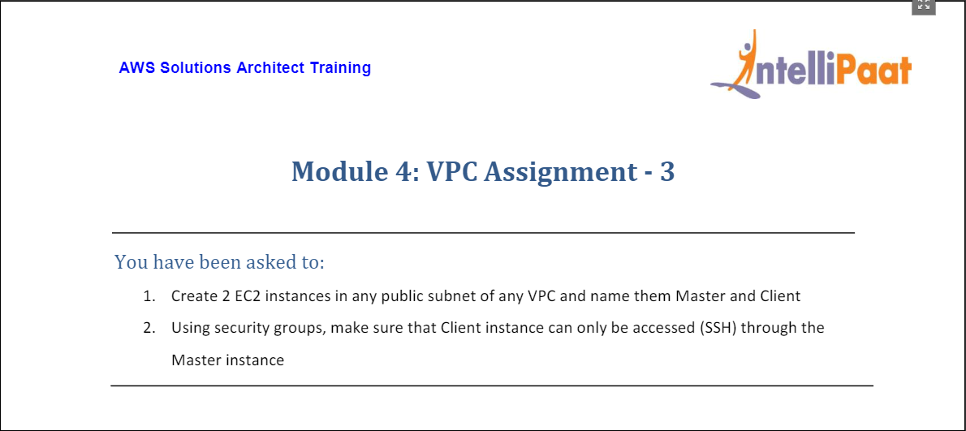

* Created public subnet (Subnet 1a) (subnet-0f29d97c458bc5f35) in VPC (myvpc1)

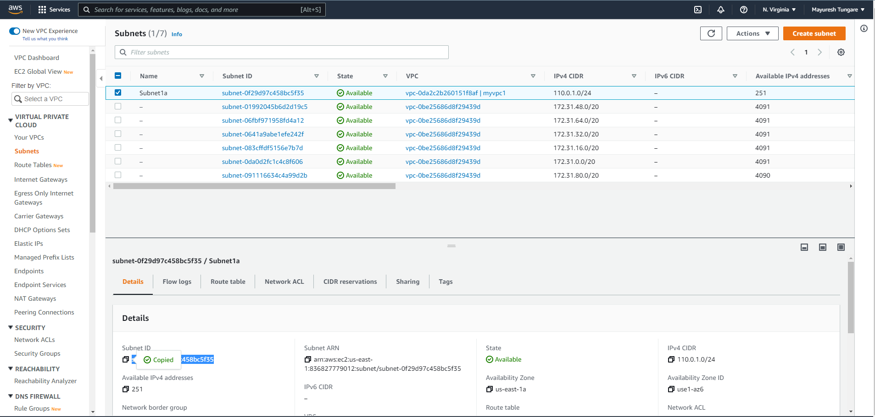

* Created and attached internet gateway (igw-0287e38fd13273a32) to make it a public subnet.

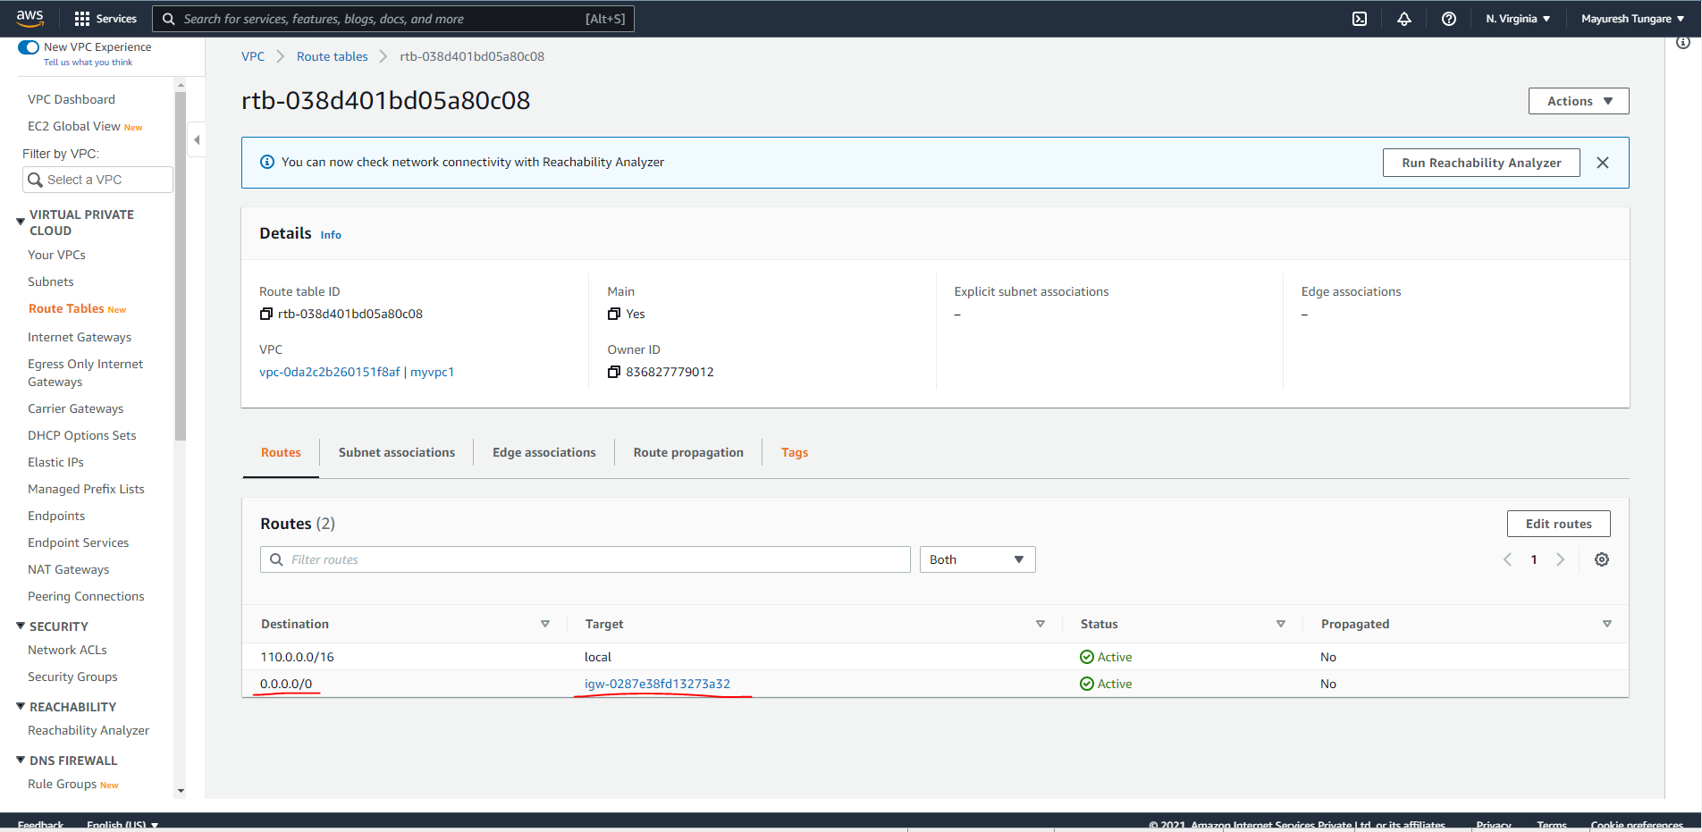

* Created two EC2 instances – **Master** (34.207.105.137) (security group launch-wizard-3) and **Client** (54.198.31.12) (security group launch-wizard-4). Note they both have different Security groups.

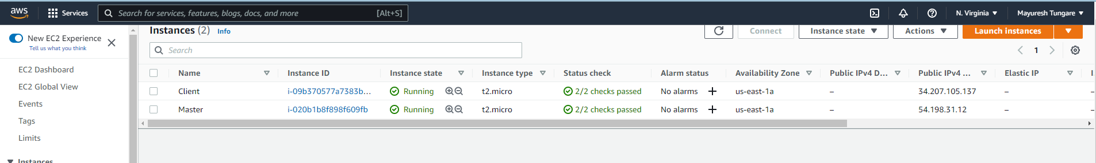

* Now, we will use to Security Groups to configure access on Client only from the Master.

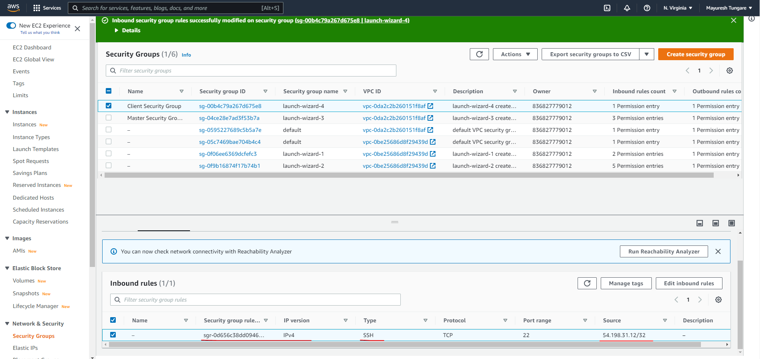

* Client is now inaccessible from local machine

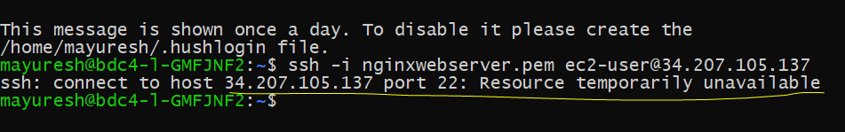

* We scp our private key into the Master instance



* We now login into master

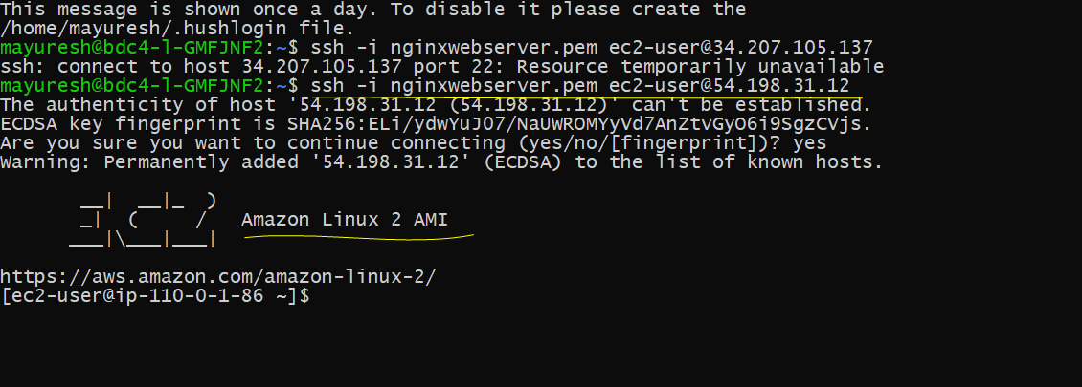

* From master, we can login to the Client instance, which remains inaccessible via local machine.

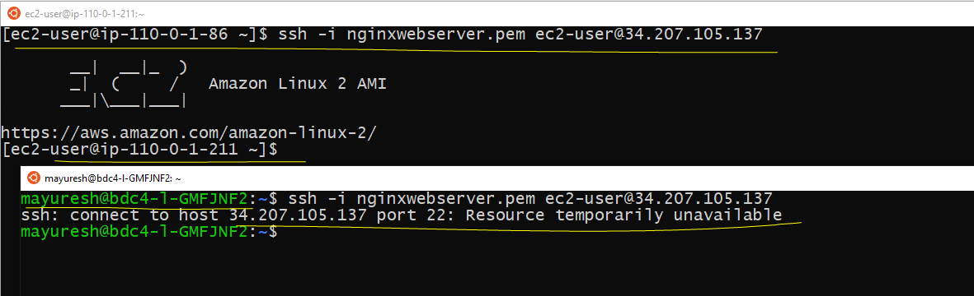

Assignment is now complete.